Home
About Us ▼
Who We Are
Our Unique Strength – History
Experience & Credentials
Vision, Mission & Values
Our Leadership
Services ▼
Consulting Services
Research & Assessments
Technical Assistance
Project Management
Sectors▼
Agriculture & Rural Development
Food Security & Livelihoods
Water Resources Management
Health & Nutrition
Education
Governance & Public Sector Development
Climate Resilience & Disaster Risk Reduction
Social Protection & Community Development
Where We Work
Structure:

Global Presence

United Kingdom
Head Office

Pakistan
Country Operations
Then:
"Experience across all provinces of Pakistan"
Map:
- Sindh
- Punjab
- KP
- Balochistan
- Islamabad
Clients & Partners
Careers
Publications & Insights
Contact Us

Page No. 1 (HOME PAGE)

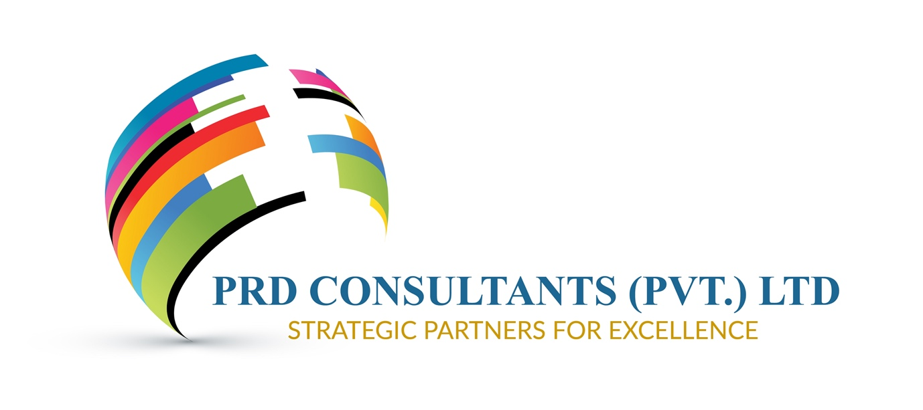WELCOME TO

PRD CONSULTANTS (PRIVATE) LIMITED
Development Consulting | Research | Technical Assistance | Project Management | Monitoring, Evaluation, Accountability & Learning (MEAL)

The Organization
PRD Consultants is an international development consulting and advisory firm operating through registered entities in the United Kingdom and Pakistan. PRD Consultants Ltd is registered with Companies House under the laws of England and Wales, while PRD Consultants (Private) Limited is incorporated under the corporate laws of Pakistan and registered with the Securities and Exchange Commission of Pakistan (SECP). Originally established under the Companies Ordinance, 1984, the company is currently governed by the Companies Act, 2017.
Building on more than a decade of development and humanitarian experience through Partners for Research and Development (PRD), PRD Consultants combines practical field knowledge with professional consulting expertise to support governments, development partners, donor-funded programmes, international organizations, NGOs, research institutions, and private sector organizations.
Through its United Kingdom Head Office and Pakistan operations, PRD Consultants provides consulting, research, technical assistance, project management, monitoring, evaluation, accountability and learning (MEAL), institutional strengthening, and strategic advisory services across a broad range of development sectors.
Supported by a multidisciplinary network of national and international experts, the firm delivers evidence-based, innovative, and context-sensitive solutions that help organizations strengthen institutions, improve programme performance, enhance accountability, and achieve sustainable development outcomes.
Delivering Evidence-Based Solutions for Sustainable Development, Institutional Strengthening, and Lasting Impact.

About Us

From Development Practice to Development Consulting
PRD Consultants was established on a simple belief: effective development solutions are built on experience, evidence, innovation, and strong partnerships.
Our journey began in 2010 through Partners for Research and Development (PRD), an organization dedicated to humanitarian assistance, community development, public health, research, training, and social development initiatives. Through direct engagement with communities, government institutions, development partners, and civil society organizations, PRD gained valuable insights into the realities of development implementation and the factors that contribute to sustainable impact.
During the floods of 2010 and 2011 in Pakistan, PRD worked alongside communities and stakeholders to support relief, recovery, and resilience-building efforts. These experiences strengthened our understanding of programme delivery, community engagement, institutional systems, and evidence-based development practice.
As development programmes became increasingly complex, results-driven, and data-oriented, the need for high-quality consulting, technical assistance, monitoring and evaluation, and strategic advisory services continued to grow. In response, PRD Consultants was established as a professional development consulting and advisory firm serving governments, development partners, donor-funded programmes, international organizations, NGOs, research institutions, and private sector organizations.
Today, PRD Consultants combines practical field experience with professional consulting expertise. Through our United Kingdom headquarters and Pakistan operations, we provide innovative, evidence-based, and context-sensitive solutions that help clients strengthen institutions, improve programme performance, enhance accountability, and achieve sustainable development outcomes.
Our unique foundation enables us to bridge the gap between strategy and implementation, transforming evidence into action and development investments into lasting impact.


CEO’s Message
Welcome to PRD Consultants (Private) Limited.
As development challenges continue to evolve, organizations need trusted partners who can combine technical expertise with practical implementation experience. At PRD Consultants, we bring together global perspectives, local knowledge, and evidence-based approaches to help governments, development partners, international organizations, NGOs, and private sector institutions achieve sustainable and measurable results.
Our strength lies in understanding both the strategic and operational dimensions of development, enabling us to deliver solutions that are practical, innovative, and responsive to real-world challenges.
We are committed to professionalism, integrity, partnership, and continuous learning, and we look forward to working with our clients and partners to strengthen institutions, improve programme performance, and contribute to sustainable development outcomes.
Aftab A. Solangi
Chief Executive Officer
PRD Consultants

There should be a button for
Our Team

Page No. 2 – Our Unique Strength

Built on a Development Legacy
What sets PRD Consultants apart is its foundation in real-world development practice combined with an international outlook. Our firm builds upon the experience and legacy of Partners for Research and Development (PRD), which has been engaged in humanitarian assistance, community development, public health, research, training, and social development initiatives since 2010.
Through years of direct engagement with communities, government institutions, development partners, and civil society organizations, PRD developed a strong understanding of the challenges and realities that influence development outcomes. This practical experience, combined with global development perspectives and standards, provides a strong foundation for our consulting and advisory services.

A Unique Combination of Practitioner and Consultant Experience
PRD Consultants combines technical consulting expertise with practical implementation experience gained through years of engagement in development and humanitarian initiatives.
This combination enables us to:
- Understand the perspectives of governments, donors, implementing partners, and communities.
- Combine international best practices with local knowledge and contextual understanding.
- Design solutions that are practical, realistic, and implementable.
- Generate evidence grounded in field realities and operational contexts.
- Bridge the gap between policy, strategy, and implementation.
- Deliver measurable, sustainable, and scalable results.
By bringing together international standards, technical excellence, and field-based experience, PRD Consultants supports organizations in addressing complex development challenges and achieving lasting impact.

From Humanitarian Response to Strategic Advisory Services
PRD Consultants’ journey began with community-focused humanitarian and development initiatives, including emergency response, public health and nutrition awareness, community mobilization, research, and livelihood support programmes.
Over time, this field experience evolved into a comprehensive portfolio of professional consulting, advisory, technical assistance, project management, monitoring and evaluation, and institutional strengthening services.
Today, PRD Consultants supports governments, development partners, donor-funded programmes, international organizations, NGOs, research institutions, and private-sector clients by delivering evidence-based solutions to complex development challenges.
By combining practical implementation knowledge with analytical expertise and international development perspectives, we help organizations translate strategies into action, strengthen institutional performance, and achieve sustainable development outcomes.

Why This Matters for Clients
Our clients benefit from solutions that are not only technically robust but also informed by real-world implementation experience. We understand the complexities of programme delivery, stakeholder engagement, institutional systems, accountability requirements, and community dynamics because we have worked within these environments.
This enables PRD Consultants to serve as a trusted partner, delivering practical, context-sensitive, and results-oriented solutions that strengthen institutions, improve programme effectiveness, and create lasting impact.

Who We Serve
PRD Consultants works with a diverse range of national and international stakeholders, including:
- Government institutions and public sector organizations.
- United Nations agencies and international development partners.
- Bilateral and multilateral donor-funded programmes.
- National and international non-governmental organizations.
- Humanitarian and relief agencies.
- Research institutions and academic organizations.
- Private sector organizations, social enterprises, and development-focused initiatives.

Our Approach
We believe sustainable development is achieved through collaboration, evidence-based decision-making, innovation, and accountability.
Our approach is built on:
- Working as trusted partners, collaborating closely with clients and stakeholders to achieve shared objectives.
- Combining local knowledge and contextual understanding with international standards and best practices.
- Delivering evidence-based, practical, and results-oriented solutions.
- Promoting transparency, accountability, learning, and continuous improvement.
- Strengthening institutional capacity and supporting locally led development.
- Developing solutions that create measurable and lasting impact.

Looking Ahead
As PRD Consultants continues to grow, our commitment remains focused on helping organizations transform ideas into action, evidence into informed decisions, and investments into meaningful development outcomes.
Through technical excellence, collaboration, and a deep understanding of development realities, we aim to create lasting value for our clients, partners, institutions, and communities.
Delivering Evidence-Based Solutions for Sustainable Development, Institutional Strengthening, and Lasting Impact.

Page No. 3 (under the page 3 sub-pages)

Vision
To be a trusted global partner in development, delivering innovative, evidence-based solutions that strengthen institutions, improve lives, and create sustainable impact for communities and organizations.

Mission
To provide high-quality consulting, research, technical assistance, project management, monitoring and evaluation, and capacity-building services that enable governments, development partners, and organizations to achieve inclusive, measurable, and sustainable development outcomes.

Our Values

Integrity
We uphold the highest standards of ethics, professionalism, transparency, and accountability in all our engagements.

Excellence
We are committed to delivering high-quality services, technical excellence, and results that create meaningful value for our clients and partners.

Innovation
We embrace creativity, learning, technology, and evidence-based approaches to address complex development challenges.

Collaboration
We believe in meaningful partnerships, stakeholder engagement, and collective action to achieve sustainable impact.

Inclusiveness
We promote equitable participation, diversity, and people-centered approaches that ensure development benefits reach all communities.

Accountability
We take responsibility for our commitments, performance, and the quality, integrity, and effectiveness of our work.

Sustainability
We support solutions that generate lasting social, economic, environmental, and institutional benefits.

Page No. 4

Experience & Credentials

Experience Built Through Practice, Partnership, and Impact
PRD Consultants brings together years of development practice, humanitarian engagement, and professional consulting expertise to support organizations in designing, implementing, monitoring, and improving development interventions.
Our experience is rooted in the legacy of Partners for Research and Development (PRD), which has been actively engaged in humanitarian assistance, community development, public health, research, training, and social development initiatives since 2010.
This foundation provides PRD Consultants with a unique advantage: the ability to combine technical consulting expertise with practical understanding of programme implementation, community realities, institutional systems, and development challenges.

Humanitarian and Community Development Experience
PRD Consultants’ foundation is built upon years of direct engagement with communities affected by emergencies, vulnerabilities, and development challenges. Through Partners for Research and Development (PRD), the organization gained practical experience in humanitarian response, community development, public health, research, and social development initiatives.
During the devastating floods of 2010 and 2011 in Sindh, PRD implemented humanitarian response and early recovery initiatives to support affected and vulnerable communities. These interventions provided valuable experience in emergency coordination, community engagement, service delivery, and recovery planning.
Key areas of engagement included:
- Emergency relief assistance for flood-affected communities.
- Distribution of food and non-food assistance to displaced and vulnerable populations.
- Support for safe drinking water, basic humanitarian needs, and community services.
- Community-based health promotion and awareness initiatives.
- Maternal and child health and nutrition awareness activities.
- Community mobilization and volunteer-led support mechanisms.
- Coordination with local institutions, government stakeholders, and humanitarian partners.
These experiences developed PRD’s strong understanding of humanitarian principles, community participation, stakeholder coordination, and sustainable recovery approaches.

Development Consulting and Advisory Experience
Building upon its practical development foundation, PRD Consultants provides professional consulting, advisory, and technical assistance services to governments, development partners, donor-funded programmes, international organizations, NGOs, humanitarian agencies, research institutions, and private sector organizations.
Supported by a multidisciplinary network of national and international experts, PRD Consultants delivers evidence-based solutions across the full programme cycle, including research, assessments, programme design, implementation support, monitoring and evaluation, institutional strengthening, and strategic advisory services.

Technical Consulting Experience
Our technical expertise includes:

Research and Evidence Generation
PRD Consultants supports organizations in generating reliable evidence to inform policies, strategies, programmes, and investment decisions.
Our research capabilities include:
- Socioeconomic and household surveys.
- Baseline, midline, and endline assessments.
- Needs assessments and vulnerability analysis.
- Market and institutional assessments.
- Feasibility studies and sector research.
- Quantitative and qualitative data collection and analysis.
- Evidence-based reporting, knowledge products, and learning documentation.
Through rigorous research methodologies and contextual understanding, we help organizations translate data into actionable insights and informed decision-making.

Technical Assistance and Institutional Strengthening
PRD Consultants supports organizations in strengthening their systems, improving programme effectiveness, and enhancing institutional capacity through tailored technical assistance and advisory services.
Our areas of support include:
- Programme design, review, and improvement strategies.
- Institutional capacity assessments and strengthening initiatives.
- Strategic planning and operational support.
- Policy analysis, development, and advisory services.
- Development of manuals, guidelines, frameworks, and standard operating procedures.
- Training, knowledge transfer, and organizational development.
- Capacity building for institutions, teams, and stakeholders.
- Technical support to improve programme quality, accountability, and sustainability.

Leadership and Expert Network
PRD Consultants is supported by a multidisciplinary network of national and international experts with extensive experience across diverse development sectors.
Our experts bring specialized knowledge and practical experience in areas including agriculture and rural development, livelihoods, governance, health, education, climate resilience, social protection, humanitarian response, monitoring and evaluation, and institutional development.
This diverse expertise enables PRD Consultants to assemble context-specific teams and provide high-quality technical solutions tailored to the needs of each assignment and client.

5. Sector Expertise Page

Experience Across Development Sectors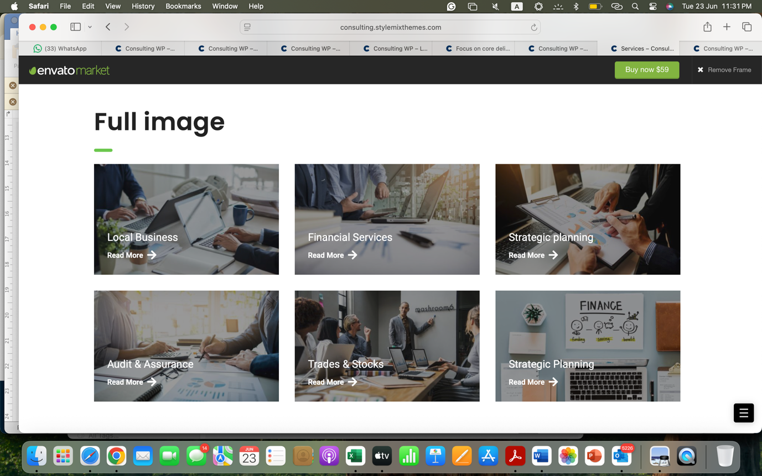
Our multidisciplinary expertise covers a wide range of sectors, including:

Agriculture and Rural Development
Supporting initiatives focused on rural livelihoods, agricultural development, food systems, and community resilience.

Food Security and Livelihoods
Supporting programmes designed to improve household resilience, economic opportunities, and sustainable livelihoods.

Water Resources Management
Providing support related to water access, resource management, and community-based solutions.

Health and Nutrition
Supporting public health initiatives, awareness programmes, health assessments, and nutrition interventions.

Education
Supporting education programmes, institutional strengthening, and learning improvement initiatives.

Governance and Public Sector Development
Supporting institutional strengthening, governance improvement, and public sector initiatives.

Climate Resilience and Disaster Risk Reduction
Supporting programmes focused on climate adaptation, resilience building, emergency preparedness, and recovery.

Social Protection and Community Development
Supporting inclusive development approaches that strengthen vulnerable communities and improve social outcomes.

Institutional and Development Partnerships
Over the years, PRD and its leadership have engaged with a diverse range of development stakeholders, including:
- United Nations agencies and international development partners.
- Multilateral and bilateral development institutions.
- Government ministries, departments, and public sector organizations.
- International and national non-governmental organizations.
- Humanitarian agencies and civil society organizations.
- Research institutions and academic organizations.
Through these engagements, PRD’s team has contributed technical expertise, research, implementation support, monitoring and evaluation, and advisory services to a range of development initiatives, including donor-supported programmes, United Nations initiatives, and World Bank-funded projects.
These experiences have strengthened PRD Consultants’ understanding of international development standards, donor requirements, programme accountability, and effective approaches to sustainable development.

Our Credentials:

The PRD Difference
PRD Consultants offers a distinctive combination of:

Field Experience
Practical understanding gained through direct engagement with communities and development programmes.

Technical Expertise
Professional capabilities in research, evaluation, advisory services, and institutional development.

Partnership Approach
A commitment to working collaboratively with clients, stakeholders, and communities.

Evidence-Based Practice
A focus on data, learning, accountability, and measurable results.

Local Understanding with International Standards
Solutions that are context-sensitive while aligned with global development practices.

OUR CLIENTS

A Trusted Partner for Development Solutions
At PRD Consultants, we believe effective consulting goes beyond providing recommendations. It requires a deep understanding of challenges, meaningful collaboration with stakeholders, and the ability to develop solutions that are practical, implementable, and sustainable.
Our experience enables us to work as a trusted partner for organizations seeking evidence-based, context-sensitive, and results-oriented solutions to complex development challenges.
By combining technical expertise, field experience, and a commitment to partnership, PRD Consultants helps clients strengthen programmes, improve institutional performance, and achieve lasting development outcomes.



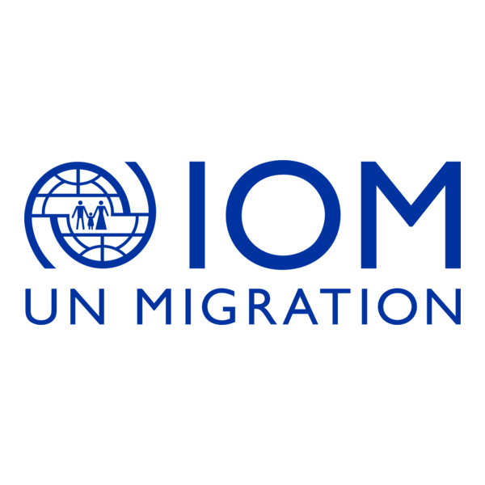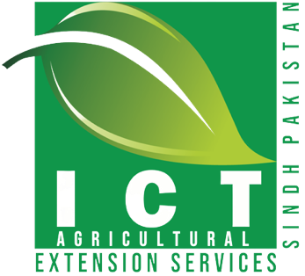

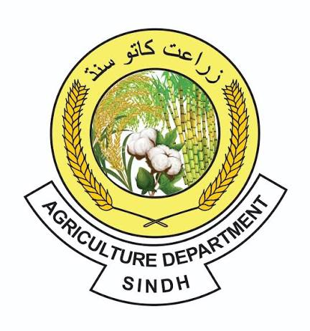

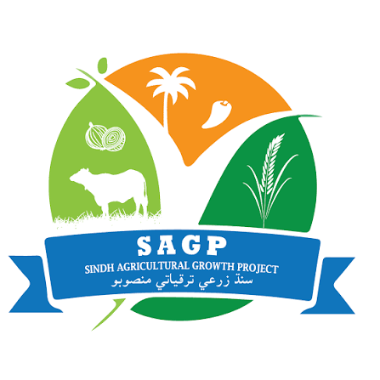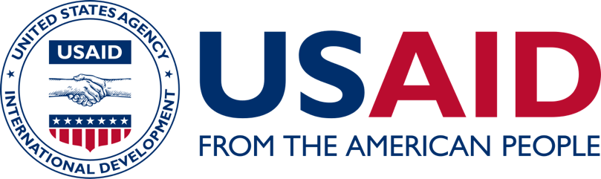





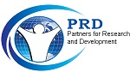


CAREERS

JOBS
CONSULTANCIES
INTERNSHIPS

Where We Work
PRD Consultants operates through its United Kingdom headquarters and Pakistan offices, combining international reach with strong local knowledge and field-based experience.
With extensive experience across Pakistan, our team and expert network have supported development initiatives in all provinces, working with communities, government institutions, development partners, humanitarian actors, and implementing organizations.
Our geographical experience includes:

United Kingdom
Our Head Office provides strategic leadership, international coordination, partnerships, and support for global development engagements.

Pakistan
PRD Consultants maintains operational presence and networks across Pakistan, with experience implementing and supporting development initiatives in:
- Sindh
- Punjab
- Khyber Pakhtunkhwa
- Balochistan
- Islamabad Capital Territory
- Other regions as required through project assignments
Through our international presence and local expertise, PRD Consultants delivers context-sensitive solutions that meet global standards while responding effectively to local development priorities.

Knowledge & Insights
Stay updated with the latest developments, achievements, and activities of PRD Consultants.
This section highlights our organizational updates, project milestones, publications, partnerships, events, and knowledge-sharing initiatives across the development sector.
Through our news and updates, we share insights from our work, celebrate collaborations with partners, and highlight contributions toward evidence-based solutions, institutional strengthening, and sustainable development.

News & Events

Publications
- Onion Research Study Sindh
- Development of PC-1 for the Sindh Water and Agriculture Transformation Project, Agriculture Department, Government of Sindh.
- Revision of PC-1 Sindh Agricultural Growth Project, Agriculture Department, Government of Sindh.

Research & Reports

Articles & Thought Leadership

Website suggestion: Instead of showing only "UNITED KINGDOM | PAKISTAN" as plain text, use an interactive map or two location cards:
🇬🇧 United Kingdom
Head Office | International Operations & Partnerships
🇵🇰 Pakistan
Country Operations | Programme Delivery & Technical Support

CONTACTS

HEAD OFFICE – UNITED KINGDOM
86 Wind Road, Ystradgynlais, Swansea, Wales, United Kingdom
Phone: +44 7304 150 461
Email: info.UK@prdconsultantsltd.com

COUNTRY OFFICE – PAKISTAN
Office No. 1, Mezzanine Floor,
25-Huma Plaza, Fazal-e-Haq Road,
Blue Area, Islamabad, Pakistan
Phone: +92 51 260 4334
Email: info.ISB@prdconsultantsltd.com

REGIONAL OFFICE - SINDH
House No. A28 & 29, Bakhtawar Colony, Opposite Abdullah Sports City, Qasimabad, Hyderabad, Pakistan.
Phone: +92 222 657 214
Email: info.HYD@prdconsultantsltd.com

